Deployment Guide

Health Check Data Protector

Version 1.0

November 30, 2021



## Document Information

|  |
| --- |
| Use Case / Content Request (UCMS) # 44269 & 53361 |
| CB Prepared by  M, Kishore <kishore.m@dxc.com> |
| Developer  CHINTALAPUDI, ANAND VARDHAN <a.chintalapudi@dxc.com> |
| Design  Sethupathy, Balaji Hamsaraj <balaji.sh@dxc.com> |
| Approved by  Sethupathy, Balaji Hamsaraj <balaji.sh@dxc.com> |
| Owning Capability  Backup |
|  |

## version history

|  |  |  |  |
| --- | --- | --- | --- |
| **Version** | **Version date** | **Updated by** | **Affected section and description of change** |
| 1.0 | 2021-11-29 | CHINTALAPUDI, ANAND VARDHAN <a.chintalapudi@dxc.com> | Initial Release |
| 1.1 | 2022-03-22 | CHINTALAPUDI, ANAND VARDHAN <a.chintalapudi@dxc.com> | 1. Userdefined OsType in Healthcheck script. 2. Credential Script for creating cred files. |
|  |  |  |  |
|  |  |  |  |
|  |  |  |  |
|  |  |  |  |
|  |  |  |  |
|  |  |  |  |
|  |  |  |  |
|  |  |  |  |
|  |  |  |  |

table of Contents

Document Information 1

version history 2

1 OVERVIEW 4

1.1 HIGH LEVEL OVERVIEW 4

1.2 Platforms and products covered 6

1.3 PREREQUISITES 6

2 Design 7

2.1 Design 7

3 Deployment Procedure 8

3.1 Backup Server 8

3.2 Dashboard 10

# OVERVIEW

## HIGH LEVEL OVERVIEW

This Automation idea is to generate Health Check dashboard for Data Protector. Here we have two Scripts, one will be run on the windows Backup Server / Jump Server which will send mails based on schedule and another is Dashboard Script, which need to run on Local machine to generate the dashboard.

The Health Check Script can be run for Windows and Unix Machines from the windows JUMP Server or Backup Server. This will perform 15 Health Checks which are as follows,

**1. DP Service Status:** It gives Percentage of Active Service Count respective to Total Service count and represented as below mentioned color in Dashboard and represented as **“D”**  if it’s **Disabled.**

|  |  |  |
| --- | --- | --- |
| **R** | **G** | **Formula** |
| <100% | 100% | Active Service Count / Total Service Count |

|  |  |  |  |
| --- | --- | --- | --- |
| **R** | **Y** | **G** | **Formula** |
| >2% | 1% to 2% | <1% | Failed Backup Count / Total Backup Count |

**2. Failed Backup count:** It gives Percentage of Failed Backup Count respective to Total Backup count and represented as below mentioned color in Dashboard and represented as **“D”**  if it’s **Disabled.**

**3. Queuing Backup Count(>30 mins):** It gives Percentage of Queuing Backup Count respective to Total Backup count and represented as below mentioned color in Dashboard and represented as **“D”**  if it’s **Disabled.**

|  |  |  |  |
| --- | --- | --- | --- |
| **R** | **Y** | **G** | **Formula** |
| >2% | 1% to 2% | <1% | Queuing Backup Count / Total Backup Count |

**4. Long Running Backup Count( >12 Hr and <24 Hr):** It gives Percentage of Long running Backup Count respective to Total Backup count and represented as below mentioned color in Dashboard and represented as **“D”**  if it’s **Disabled.**

|  |  |  |  |
| --- | --- | --- | --- |
| **R** | **Y** | **G** | **Formula** |
| >2% | 1% to 2% | <1% | Long running Backup Count / Total Backup Count |

**5. Long Running Backup Count( > 24 Hr):** It gives Percentage of Long running Backup Count respective to Total Backup count and represented as below mentioned color in Dashboard and represented as **“D”**  if it’s **Disabled.**

|  |  |  |  |
| --- | --- | --- | --- |
| **R** | **Y** | **G** | **Formula** |
| >2% | 1% to 2% | <1% | Long running Backup Count / Total Backup Count |

**6. Disabled Tape Drive Count:** It gives Percentage of Disabled Tape Drive Count respective to Total Tape Drive count and represented as below mentioned color in Dashboard and represented as **“D”**  if it’s **Disabled.**

|  |  |  |  |
| --- | --- | --- | --- |
| **R** | **Y** | **G** | **Formula** |
| >2% | 1% to 2% | <1% | Disabled Tape Drive Count / Total Tape Drive Count |

**7. Scratch Media Count:** It gives Percentage of Free Media Count respective to Total Media count and represented as below mentioned color in Dashboard and represented as **“D”**  if it’s **Disabled.**

|  |  |  |  |
| --- | --- | --- | --- |
| **R** | **Y** | **G** | **Formula** |
| <10% | 10% to 20% | >20% | Free Media Count / Total Media Count |

**8. IDB BKP Status:** It is Red in color if IDB Backup is failed and represented as Green if IDB Backup is Completed and represented as **“D”**  if it’s **Disabled.**

|  |  |
| --- | --- |
| **R** | **G** |
| Failure | Success |

**9. Critical Backup Status:** It gives Percentage of Completed Critical Count respective to Total Critical count and represented as below mentioned color in Dashboard and represented as **“D”**  if it’s **Disabled.**

|  |  |  |
| --- | --- | --- |
| **R** | **G** | **Formula** |
| <100% | 100% | Completed Critical Backup Count / Total critical Backup Count |

**10. Free Disk Space:** It gives Percentage of Free Disk Space respective to Total Disk Space and represented as below mentioned color in Dashboard and represented as **“D”**  if it’s **Disabled.**

|  |  |  |  |
| --- | --- | --- | --- |
| **R** | **Y** | **G** | **Formula** |
| <10% | 10 to 20 % | >20% | Free Disk Space / Total Disk Space |

**11. Free Disk Space DataDisk:** It gives Percentage of Free DataDisk Space to respective Total DataDisk Space and represented as below mentioned color in Dashboard and represented as **“D”**  if it’s **Disabled.**

|  |  |  |  |
| --- | --- | --- | --- |
| **R** | **Y** | **G** | **Formula** |
| <10% | 10 to 20 % | >20% | Free DataDisk Space / Total DataDisk Space |

**12. Library Status:** It gives Percentage of Active Library Count respective to Total Library count and represented as below mentioned color in Dashboard and represented as **“D”**  if it’s **Disabled.**

|  |  |  |
| --- | --- | --- |
| **R** | **G** | **Formula** |
| <100% | 100% | Active Library Count / Total Library Count |

**13. Hung Backup Count:** It gives Percentage of Hung Backup Count respective to Total Backup count and represented as below mentioned color in Dashboard and represented as **“D”**  if it’s **Disabled.**

|  |  |  |
| --- | --- | --- |
| **R** | **G** | **Formula** |
| >0% | 0% | Hung Backup Count / Total Backup Count |

**14. Mount Request Count:** It gives Percentage of Free Media Count respective to Total Media count and represented as below mentioned color in Dashboard and represented as **“D”**  if it’s **Disabled.**

|  |  |  |  |
| --- | --- | --- | --- |
| **R** | **Y** | **G** | **Formula** |
| >2% | >0% & <2% | 0% | Mount Request Backup Count / Total Backup Count |

**15. Disabled Backup Job Count:** It gives Percentage of Disabled Backup Count respective to Total Backup count and represented as below mentioned color in Dashboard and represented as **“D”**  if it’s **Disabled.**

|  |  |  |  |
| --- | --- | --- | --- |
| **R** | **Y** | **G** | **Formula** |
| >5% | < 5% | 0% | Disabled Backup Count/Total Backup Count |

## Platforms and products covered

Windows Platforms

 Windows 2003 |  Windows 2008 |  Windows 2012 |  Windows 2016

UNIX Platforms

AIX |  HP-UX |  Linux Red Hat |  Linux SUSE |  SunOS (Solaris)

Backup Products

 Avamar (AV) |  Legato |  NetBackup |  Tivoli Storage Manager

## PREREQUISITES

* Script Hosting System should have powershell version 3.1 and above.
* WINRM service should be enabled on the Hosting & Windows backup servers.
* Automation user should have necessary permission to access all the BKP Application directories without sudo access.

# Design

## Design

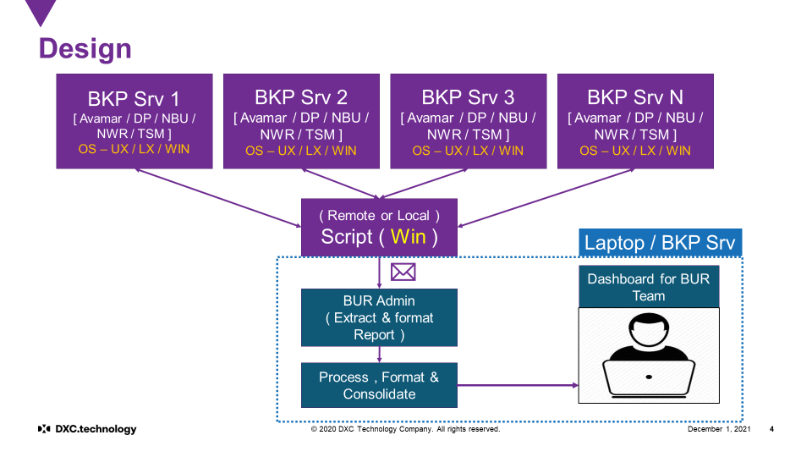

# Deployment Procedure

## Backup Server

Logon to the Windows Backup Server or the Jump Server and copy the solution to any directory and create folder as **BURAuto\HC.**

Please find the zip file in share point as **“HC-DP.zip”.**

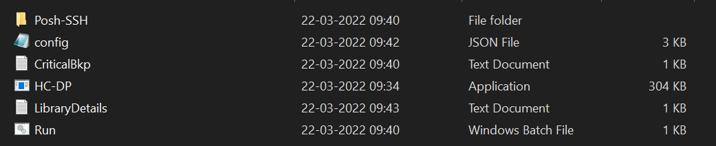

* Before Extracting go to the properties of Zip file and unblock the file if it is blocked.
* Provide the required fields in the **config file(config.json)**,**criticalbackup.txt** and **librarydetails.txt** in the folder and run the **run.bat** file.
* This will ask the user credentials to logon to Windows Backup server or Linux Backup server for remote connections and it does not require any credentials for running locally on windows Backup Server.
* This will create **cred.xml** file with given credentials which is encrypted.
* Schedule the **run.bat** file accordingly.
* If you have more than one backup server , create separate directory with the servername and perform the steps mentioned above.

**Config.json Parameters:**

**Info 1:** Change the parameters under this category accordingly.

* **Account :** Provide the Account name.
* **BackupServer:** 
  + **Remote:** Provide the BackupServer name of Windows or Linux Machine
  + **Local:** Localhost.
* **ReportPath:** Provide the path of **BURAuto\HC** folder separated by **“\\”.**

Eg: C:\\ BURAuto\\HC

* **OsType:** Provide as **Windows** or **NonWindows**

**Enabling and Disabling Health Checks:**

**Enabled :** Enables the Health Check

**Disabled:** Disables the Health Check

* **ServiceHealthCheck:** Enabled or Disabled Accordingly.
* **Queuing:** Enabled or Disabled Accordingly. If Disabled the following HealthChecks

also gets Disabled.

* + Queuing Backup Count(>30 mins)
  + Long Running Backup Count( >12 Hr and <24 Hr)
  + Long Running Backup Count( > 24 Hr)
  + Hung Backup Count
  + Mount Request Count
* **DisabledTapeDriveCount:** Enabled or Disabled Accordingly.
* **ScratchMediaCount:** Enabled or Disabled Accordingly.
* **FailedBackupCount :** Enabled or Disabled Accordingly. If Disabled the following HealthChecks also gets Disabled.
  + Failed Backup count
  + Critical Backup Status
* **LibraryStatus:** Enabled or Disabled Accordingly.
* **FreeDiskSpace:** Enabled or Disabled Accordingly. If Disabled the following HealthChecks also gets Disabled.
  + Free Disk Space
  + Free Disk Space DataDisk
* **DisabledBackupJob:** Enabled or Disabled Accordingly.
* **Datadisks:** 
  + **Windows:** Provide the Drive letter where DP is installed, separate with **“;”** if there are multiple Drives.

Eg: “C;D” or “E”

* + **Linux:** Provide the Mountpoint where DP is installed, separate with **“;”** if

there are multiple MountPoints.

Eg: “/var/opt/omni” or “/var/opt/omni; /opt/omni/”

* **SmtpServer:** Provide SMTP details.
* **To:** Provide the To address, separate with **“;”** if there are multiple addresses.

Eg: “[example1@dxc.com;example2@dxc.com](mailto:example1@dxc.com;example2@dxc.com) “ or “ example@dxc.com”

* **CC:** Provide the CC, separate with **“;”** if there are multiple addresses.

Eg: “[example1@dxc.com;example2@dxc.com](mailto:example1@dxc.com;example2@dxc.com) “ or “ example@dxc.com”

**Info 2:(ONLY UNIX)**

* Change the paths under this category in case of **UNIX** if paths used are different.

**Info 3:**

* Do not change the parameters under this category.

**CriticalBkp.txt Parameters:**

Provide the Critical Specifications that you want to monitor.

CriticalBkp.txt contain Backup specification in below format

JobName

Specification1

Specification2



**LibraryDetails.txt Parameters:**

Provide the library details that you want to monitor.

LibraryDetails.txt contain details in below format

ConnectionType, ConsoleIP, UserName, Password

Example:-

SSH,10.10.10.102,User1,Pass123 – If connection to Library is Remote

Local, HP:MSL6480_peburdp01 – If connection to Library is Local



## Dashboard

* Please find the zip file in share point as **“HC_Dashboard.zip”.**
* Extract the Dashboard Solution.

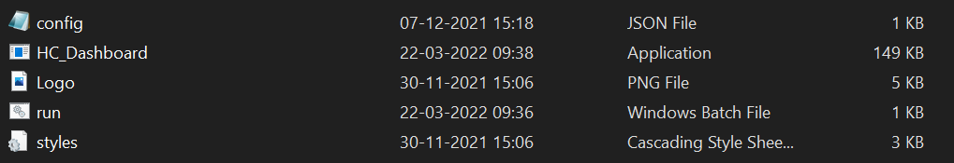

* Create a Rule in the outlook with **“BUR Automation <do.not.reply@dxc.com>”** and create a folder **“Inbox\BURAUTO\HC”** so as to redirect all BUR Health Check mails to that folder.
* Provide the required fields in the **“config.json”.**
* Run the **“Run.bat”** file.
* A HTML file will be opened in Default Browser or it will be available in Dashboard folder as **“Index.html”.**

**Config.json Parameters:**

* **Mailbox :** Provide your mail address.
* **MailLocation:** Provide the path of outlook folder.
* **senderMailAddress :** Provide the sender email id.

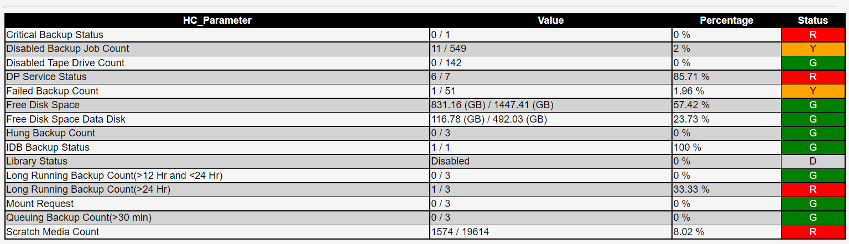

## Credential Script

* If Health-Check is deployed for multiple servers which have different password for each, use Create-Credential solution to create credential file (cred.xml).
* Please find the zip file in share point as **“Create-Credential.zip”.**

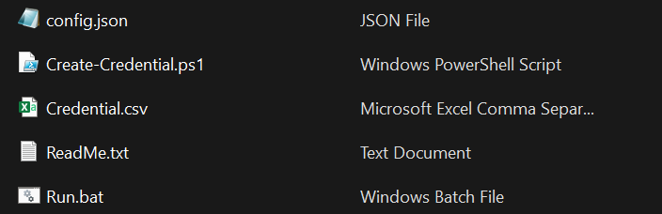

* Provide the usernames, password and paths for the respective servers in credential.csv.
* Run the run.bat file which generates the credential file(Encrypted) in the respective server folders.
* Passwords will be removed from csv after running the script.

## Licence

* The user requires key to run the HealthCheck and Dashboard solutions.
* User need to acquire password from Backup SME or Automation Team.
* Provide the Domain name of the Account where the solutions needs to be run.
* If the HealthCheck solution hosting system and Dashboard solution hosting system are different, request for two licences for both the domains.
* The key provided to you will be like **“Key_DomainName”.** Please rename it to just **“Key”** and place it along with the other files of the solution.
* The key provided to user will be valid till **June** or **December** of that year.
* User needs to request for new key in the month of June or Ddecember for renewing it for the next 6 months.

**Creating Rule in Outlook:**

**A:** Click on File

**B:** Select manage Rules and Alerts

**C:** Click on New Rule

**D:** Under Start From Blank Rule, Select Apply Rule on messages I receive and click Next.

**E:** Select the below mentioned two rows in 1st step of that window.

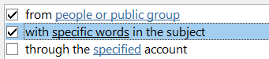

**F:** Open the below mentioned two rows in 2nd step of that window and provide

**“BUR Automation <do.not.reply@dxc.com>”** in people or public group From field and

**“Health Check”** specific words part and click ok.

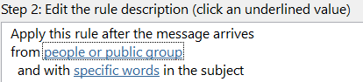 

**G:** Select the below mentioned row in 1st step of that window.



**H:** Open the move to **Specified** row in 2nd step of that window and create a new folder as

“**BURAuto_HC**” and click finish.

